Draft Objection to Bolney Lane Planning Application

Dear SODC Planners

OBJECTION — Planning Application PP-14718534 / P26/S1042/O
Up to 60 dwellings — Land South of Bolney Lane and East of Reading Road, Lower Shiplake

I write to object in the strongest possible terms to planning application PP-14718534 / P26/S1042/O for up to 60 dwellings, on land south of Bolney Lane and east of Reading Road, Lower Shiplake.
I would also like to register my concern at the quite limited degree of circulation to residents inviting comment, for what is a quite massive speculative development in the open Countryside, and which will potentially have very wide impacts if it proceeds.
Given the nature of the development its potential impacts on Lower Shiplake and Reading Road, I certainly and am sure others will be quite surprised not to have been directly informed by SODC of the existence of this Application but rather had heard about it locally like I have.
The Application is in my view poorly drawn, fails to provide sufficient information for the proper consideration of the proposal that it seeks to achieve outline consent for, and as such should either be withdrawn, updated and resubmitted, or the Application refused.
SODC and local residents have had to suffer 10 years of uncertainty, debate, and costs; not to mention the significant blighting effect of, a poorly conceived plan to develop land at Thames Farm. The format of the subject Application, and lack of content and due diligence information risks a further such situation arising, which is almost inevitable with the lack of adequate supporting information and full and proper site investigations that this Application demonstrates.
Given the history of Thames Farm and arguably the mistake made at the time the Outline Consent was first granted, I would urge SODC to take immediate action to stop such recurrence, and require submission of much greater detail.
The fundamental point here, is that it is not acceptable, particularly with the history and knowledge of the Thames Farm debacle, and the status of this site within the same SPZ1 over the Principal Aquifer, for a developer/owner, to put forward such an ill-conceived, poorly researched and largely unsupported case for the development of land in the open countryside.

- The Application as it sits fails to demonstrate that these proposals are remotely feasible, practically possible to achieve; nor assesses the impacts that such development might have on a variety of key issues, not least of which comprise inter alia:-

- The SPZ1 and underlying aquifer,
- The nearby potable bore holes operated by Thames Water
- The existence or otherwise of dissolution features within the site and how these might impact on foundation design/necessary groundworks and or engineering operations that might be required to enable the site development to go ahead.
- The impacts of any such groundworks on the SPZ1 and Aquifer, and the potable bore holes
- The ability to safely and properly drain the site in a SuDS compliant manner
- The potential for flooding to occour on and off site
- Highway impacts and safety concerns
- The onsite public right of way and its meeting point with the proposed vehicular means of access/on site roads
- The means by which foul drainage is not only to be managed and connected through to the already over burdened local drainage network, as well as the major capacity issues that exist both on this side of the river Thames, beneath the river and at the sewerage works at Wargrave.

The Appended drainage report (desk based) suggests that the site is “capable of being drained” and that “……..suitable arrangements for the disposal of foul water effluent……. is capable of being provided” That frankly is a somewhat disingenuous series of statements which underline the deficiency in investigations and adequacy of due diligence by the Applicant. In short, anything is possible given adequate time and adequate funds in the hands of the providers. That does not mean that the site can be developed within a reasonable period of time.

- The Shiplake Neighbourhood Plan (SNP) was ‘made’ in September 2022, and remains in force and up to date. The plan does not and is not required to allocate any housing, but seeks to protect the rural character of Lower Shiplake and Shiplake Cross.

Policy SV1 of the Shiplake Neighbourhood Plan is a local interpretation of Policy H16. The built-up area (the BUA) of Lower Shiplake is demarcated with a boundary as shown in figure 12 of the SNP, and also defines a separate built up area for Shiplake Cross.

The proposed development falls out with the BUA for Lower Shiplake and as such also does not constitute infill development within the meaning ascribed by the Local Plan. The proposal is therefore contrary to Local Plan Policies STRAT1, H1, H8 and H16 and SNP Policy SV1.

Lying outside the BUA the site therefore lies in the countryside in planning policy terms. SNP Policy SV2 will only support additional dwellings in the open countryside if they are necessary or suitable for a countryside location. The proposed 60 dwellings do not fall within any of the categories of acceptable countryside development. Hence the proposal is contrary to Policy SV2.

As the appeal site lies outside the defined BUA boundary of Lower Shiplake, the proposal would conflict with the Council’s spatial strategy and hence would not be a suitable location for housing regarding local and national policies. Accordingly, the proposal would be contrary to Local Plan Policies STRAT1, H1, H8 and H16 and SNP Policies SV1 and SV2.

- This site coupled with the information regarding the SPZ1, the Aquifer, the make up of the ground at Thames Farm and its dissolution features, the proximity of the potable bore holes used by Thames water, the designation of flood zone 2 and a number of other important factors all strongly suggest that this site and the development proposals should be required to undertake an EIA as part of the consideration process. It is of note that the Applicant owns land nearby and adjacent to the development site boundaries and that in a variety of places the site is actually referred to as being 5.28 HA and not 4.95 HA. This includes the Applicants own Geotechnical report (see executive summary).

I therefore believe it appropriate and hugely necessary for the Applicant to be asked to prepare an Environmental Impact Assessment for the Development or in default to be the subject of a screening exercise to verify the need or otherwise. This is also referred to below in the section dealing with the issues of Geotechnical Information, potential Solution features and the matter of groundworks and/or foundation design.

- The Ground information report submitted with this outline application freely admits not only the possibility but also the strong likelihood that the site will be subject to a variety of dissolution features. Indeed there are 8 confirmed such ‘dissolution pipes’ referred to in the Applicants own desktop Envirocheck Report.

Once again this is simply an unacceptable approach to such a fundamental matter in an outline application of land within the defined Open Countryside. Simply throwing in a plan plus a red line with wholly insufficient support information does not work, is lazy and unacceptable and places a kind of burden of proof upon the Planning Authority. The burden of proof in a massively sensitive setting lies with the Applicant who seeks to change the current status quo and the re-allocation of land designated Open Countryside to an intensive developed use of land in a highly sensitive setting.

- Heavy Metals

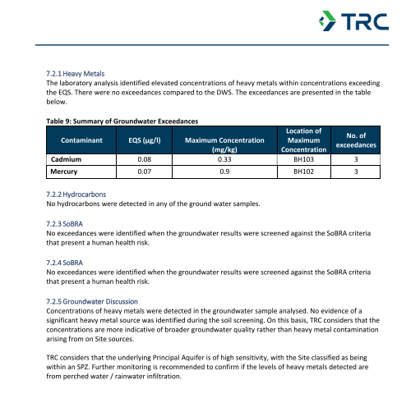

Once again an important issue highlighted by the above extract of the Applicants submission report, is identified and pushed into the ‘long grass’ as a matter which can but has not been investigated adequately.

- Foundations, Nature and Design/EIA Requirement. The applicants reports refer to the preliminary nature / subject to further investigations of what has been submitted. This Approach failed drastically at Thames Farm, and culminated in the ultimate need to submit a wholly new Planning Application for the Approval of groundworks that were considered necessary (and determined as such by an Application to the Secretary of State) to enable the site to be developed for Housing, and comprised a wholly separate operation in Planning terms that required separate Planning Approval. It should also be noted, that it was a further determination by the Secretary of State that the risks posed to the site and environment were such that a full Environmental Impact Assessment/Study was required once it had been established that the ground was subject to significant dissolution features and that such extensive ground works were said to be necessary to enable the site to be prepared in order to support the subsequent development of the housing for which the site already had Planning Permission.

- Groundwater Levels. There is insufficient factual information including data upon seasonal variations to adequately assess the risk to the Ground Water. The applicants report highlights the sloping nature of the site and high water table, and that “ The groundwater monitoring was undertaken in Autumn, and therefore the results may not represent the worst case credible scenario. Therefore groundwater levels could be seasonally higher and should not be discounted to be encountered within excavations…..”

It is further noted that additional testing is recommended to verify pH values and the classification of the site conditions in relation to any Aggressive Chemical Environment for Concrete

- Conceptual Site Model (CSM) Risks The Applicants Report highlights what they describe as ‘Groundwater sensitivity’ - “A Moderate to High Risk due to the EA’s designation of groundwater as a Secondary (A) AND Principal Aquifer”

The report goes on to say (Section 12.3 Summary of Geotechnical Assessment) that further investigations and assessment is required to quantify the potential solution features risk and to inform the foundation design. It is also stated that in higher risk areas “……a piled foundation design could be considered should this be more cost effective. A piled foundation solution will likely trigger the need for a pile risk assessment from the Environment Agency, given chalk is a principal Aquifer”.

In short, the Applicant is making an educated guess (based on wholly insufficient factual knowledge) of what Ground works / Foundations might work in this location. The need or otherwise for any grouting work is not even referred to but clearly cannot at this stage be discounted. It is however notable that the ground water is at a significantly elevated level in this location as compared to that found at Thames Farm.

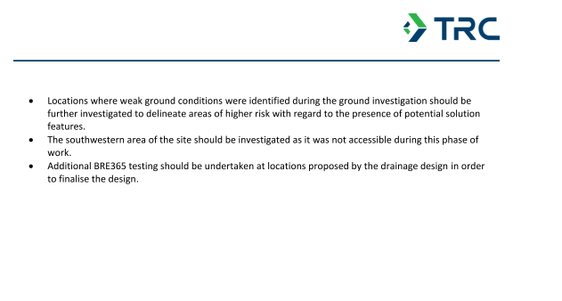

Extent of the very limited Intrusive Investigations

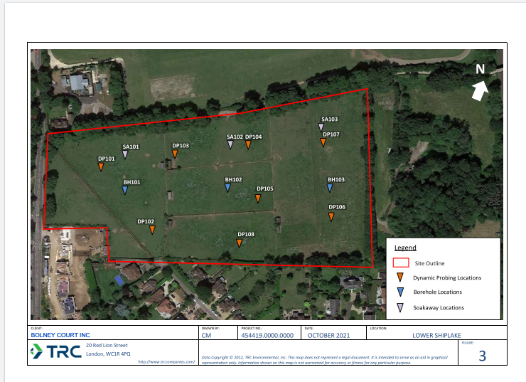

- Trees/ Views/ Vista / Heritage Buildings Setting and Views. SODC's own Tree Officer has already recognised the risk. Tree Preservation Order 25S07 was made on 5 November 2025, protecting 51 mature Horse Chestnut trees along Bolney Lane — 25 on the north verge (Group G1) and 26 on the south verge (Group G2) — specifically because of the threat of residential development on the Pony Field. The statutory notice states the order was made because the Forestry Team was informed of possible residential development on land to the east of Reading Road and south of Bolney Lane known as the ‘Pony Field’ which could result in foreseeable damage to trees.

There is clearly a major and accepted concern regarding the risk to Trees along Bolney Lane from this potential development hence this designation. Equally consequential but not highlighted is the damage that this proposal would wreak upon the views and vistas from Reading Road, from the existing local housing, Northfield Avenue and the PRoW, and of course from the site itself.

The Landscape and Visual Report appended to the Application speaks of preserving Character, Important Views and respecting the existing settlement pattern and local circumstances and to visually enhancing local character.

The proposed development sited in Open Countryside will on the contrary do exactly the opposite to what the report suggests. Whilst it may be said that the Tree Lined Bolney Lane will be preserved and protected, which with the recent TPO designations could hardly be considered otherwise, the proposals directly attack the Local Countryside, the Intrinsic Gap between Henley and Lower Shiplake and will completely cut off the views and vistas presently available from the South West of the site and from the Reading Road. A huge 2/3 storey development in this location comprising 60 houses compressed into a relatively small part of this site.

Moreover, the site sits squarely within and on the Southern edge of 14G River Valley – Caversham to Henley Thames Lower Valley area and will do permanent and irrevocable damage to that area; and also when viewed from the area further South which comprises the current site and other adjacent land presumed to be owned by the same parties.

- Tilted Balance -The Applicant makes much of the ‘Tilted Balance’ concept, as a means of getting a ‘free pass’ to development. However this concept was tested but a short while ago and considered by the Planning Inspectorate in the matter of the site at New Road Shiplake (Appeal Ref: 6003006, Inspector K Stephens, 9 April 2026.). The Inspector in that case had some similar issues to consider when he dismissed an Appeal in respect of 25 Houses, but which had far fewer strategic problems than the subject site. The primary issue tested there was the balance of harm v good in relation to a much more centrally placed site and with far fewer ‘technical’ reasons to refuse than the subject site. The site is in a relatively quiet private roadside location, hence did not have the issue of being accessed from a major A road with fast moving traffic travelling by.
His decision was a clear victory for common sense and the recently made SNP protecting the open countryside from unwanted speculative housing development; the Appeal was dismissed just last month.

- Pre-Application Survey. - The pre-application community consultation survey referred to by the Applicant did not constitute full and proper community engagement. It offered no option for 'no development' or 'no houses' and hence compelled respondents to choose between development variants rather than registering fundamental opposition. The majority of questions presupposed that development would occur, focusing on design details rather than the principle of whether it should happen at all. This structure was designed to produce results that appear to show community support when a majority of residents clearly do oppose the scheme outright.

Over 100 local residents signed a formal objection letter to SODC in October 2025 — before this application was even submitted — demonstrating the depth and breadth of local opposition. NPPF paragraphs 128–132 require genuine, open and representative pre-application community engagement. The applicant's survey does not meet that standard. Neither has the Applicant been sufficiently confident in its reasons to transparently publish the comprehensive aggregated results of this exercise. SODC should give the survey results no weight as evidence of community support.

Summary

I set out below to assist SODC a summary of the important issues here and relevant policy matters.

This Open Countryside Development proposal is fundamentally flawed both conceptually as a proposal to develop in the Open Countryside, but also because of the completely insufficient and incomplete nature of the Application itself .

With a site in the location concerned and with the potential to do huge irreversible harm to the local environment, there are no grounds as to why this Application should be seriously considered for approval. Without the level of adequate due diligence that is required to genuinely even give consideration to the principle of development, as stated in my opening paragraphs, this Application should either be withdrawn and reconsidered re submitted with a comprehensive package of design, environmental impacts and access data, or rejected out of hand as wholly deficient.

It is also important to note that perhaps due to SODC’s newly installed Planning Portal system, the level of public consultation being undertaken for this Application is wholly deficient, should be recommenced, and be undertaken to a much wider audience.

Should officers be considering recommending approval in any form, I would respectfully ask that the matter be considered by the full Planning Committee.

POLICY REFERENCE TABLE

Ground | Key Policies | One-line argument
1,3, 4, 5, 6, 7,8 - Insufficient Information | N/A | Wholly inadequate submission, complete lack of understanding of the Issues and the necessary information required to address.
2 – Neighbourhood Plan | SNP SV1, SV2, SV8a, SV11, SV7, SV8, SV15; SODC ENV1 | SNP made to protect this village edge. Developer tried to weaken these policies during NP process. All policies remain in force.
2.– Local Plan conflict | SODC STRAT1, H1, H8, H16; SNP V2, para 6.4.40(a); Henley & Harpsden NP | Applicant admits breach. SNP 6.4.40(a) protects this rural approach. 80% vote against outside-settlement development.
3. – Lack of Environmental Impact Study/Assessment | N/A | Complete lack of assessment of Impacts on the environment
5 – Heavy Metals | N/A | Insufficient data to consider
6 – Ground Works/Foundations/Solution Features | N/A | Insufficient due diligence Information
7 – Ground Water | N/A | Insufficient Data/inadequate Sampling
8 - CSM | N/A | There is no real understanding of the nature of the ground conditions
9 – PLCA3 Conflict and TPO 25S07 | SODC ENV1; SNP SV15; TCPA 1990 s.198 | 51 trees protected by SODC specifically because of this development, as well as PLCA3 Conflict with SNP and other local designations
10 – Tilted balance | NPPF para. 11(d); Appeal Ref: 6003006 (April 2026) | Harms outweigh benefits. Not a free pass. New Road appeal (April 2026) dismissed on same grounds — Inspector found tilted balance inapplicable as SNP has no allocations. Refused at 3.81yr supply.
11 – Community Survey | N/A | Deficient and not published
12 – Cumulative scale | SODC STRAT1, INF1 | No cumulative assessment. Smaller Village already over-developed.
13 – Pump station | SODC INF4, EP3; SNP SV18 | Undesigned pump station 20m from homes. Unacceptable at outline.
14 – Sewer loading | SODC INF4; SNP SV18 | Thames Farm adding pumped foul to same sewer. No combined assessment.
15 – Wargrave STW / river quality | SODC INF4, ENV4; SNP SV18; NPPF 174, 186 | Oxford Rivers/UKCEH data confirms frequent untreated discharges. River quality deteriorating. Treatment capacity unconfirmed.
16 – SPZ1 aquifer | SODC INF4, ENV4; NPPF para. 187 | Same aquifer as Thames Farm. Sinkholes acknowledged. EA not responded. 50,000 people's water.
17 – Highway safety | SODC TRANS5; SNP SV19; NPPF 115–116 | 40.7mph at access. Simple T-junction inadequate. A4155 dangerous at school run. No Stage 2/3 RSA.
18 – Station/village parking | SODC TRANS2, TRANS5; SNP SV19 | Station full by 7am. Only 3-4 public spaces at village shops. Northfield Ave/Station Rd/Mill Rd crossroads a dangerous parking hotspot.
19 – Sustainability | SODC TRANS2, TRANS5; SNP SV19 | Only 3-4 public parking spaces at village amenities. Car dependency certain.
20 – Bolney Lane | SODC ENV1; SNP SV7, SV8, SV8a, SV15 | Rural gateway permanently urbanised. TPO 25S07 protects 51 trees.
21 – PRoW/Chiltern Way | SODC ENV1; SNP SV8, SV20 | Countryside routes permanently degraded. Rural transition to AONB lost.
22 – Ecology/BNG | SODC ENV3, ENV5; SNP SV13, SV15 | BNG aspirational. Dark corridors unenforceable. No independent review.
23 – Outline Nature of Application | SODC EP4, INF4, ENV9; NPPF | Drainage, sewage, ecology, archaeology, TPO, Groundworks and all environmental impacts unresolved.

